**SSH Using Windows**

Before attempting to login to TACC systems you will need to create a TACC user account. Visit TACC’s “Getting Started” website for a tutorial that will guide you through the basic steps to create your TACC user account: <https://www.tacc.utexas.edu/use-tacc/getting-started>

**PowerShell:**

* Press the Windows key and type “terminal”.
* Select the app from the Start menu to launch powershell.
* Type “ssh” and hit Enter. If OpenSSH is activated on your computer, you should see output as shown in the screenshot below. If not, please see the section titled “Install OpenSSH Client”.

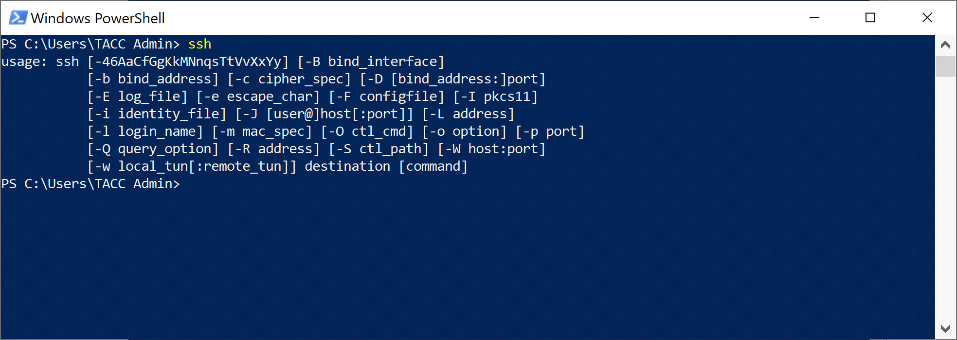

* Type **“ssh** **your_username@taccmachine.tacc.utexas.edu”** and hit Enter. You may see a message about the authenticity of the host and key fingerprints. Type “yes” to continue connecting.
* Use your TACC password and TACC MFA Token to login.

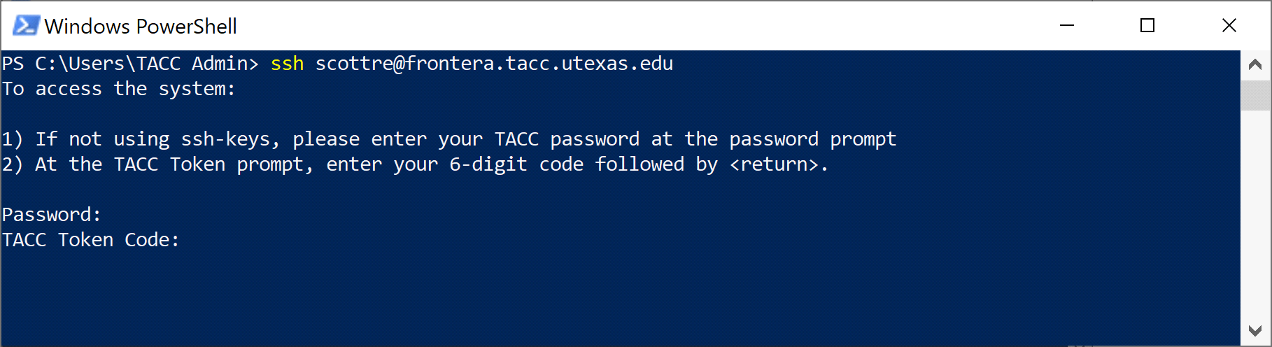

* If you are successful, you should see something that looks like the screenshot below.

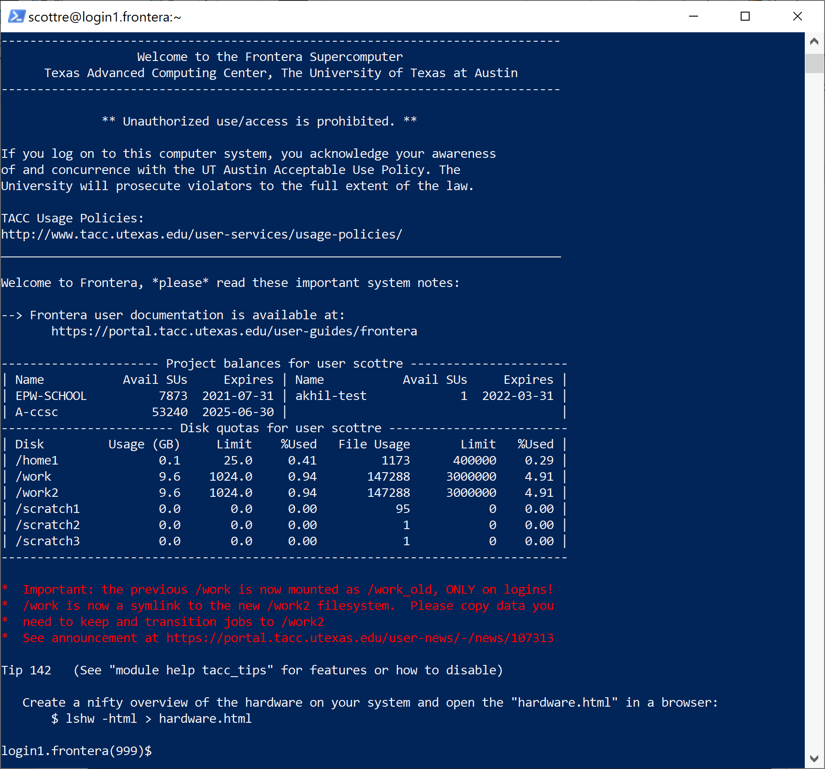

**Install OpenSSH Client**

Navigate to the following:

* Settings
* Apps
* Optional Features
* Click the “Add a Feature” button
* Search for “OpenSSH Client”
* Select “OpenSSH Client” and click the “Install” button
* Reboot

**PuTTY:**

* Launch the PuTTY app.
* In the Session category, ensure your connection type is SSH, then type the hostname of the remote system you want to ssh to into the “Host Name” filed, in the case of the screenshot below, **frontera.tacc.utexas.edu**, and click the “Open” button.

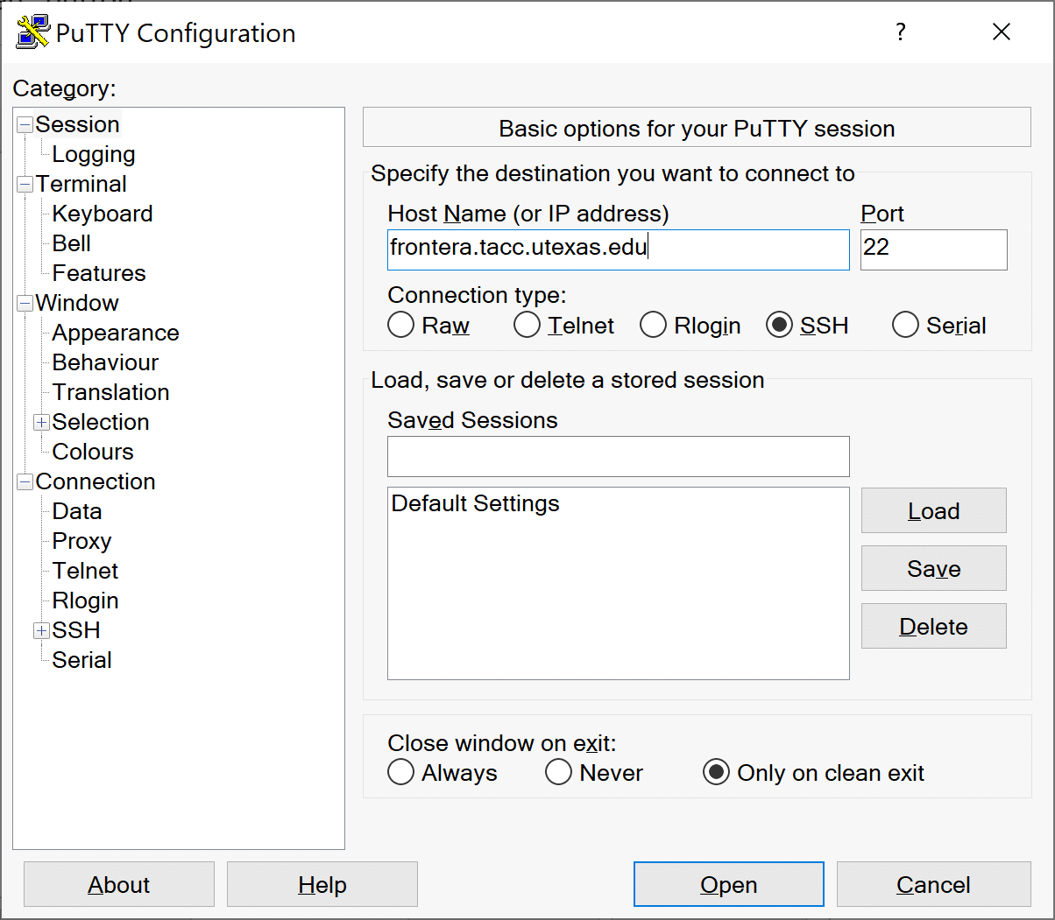

* You will then be prompted for your username, TACC password, and TACC MFA Token to login.

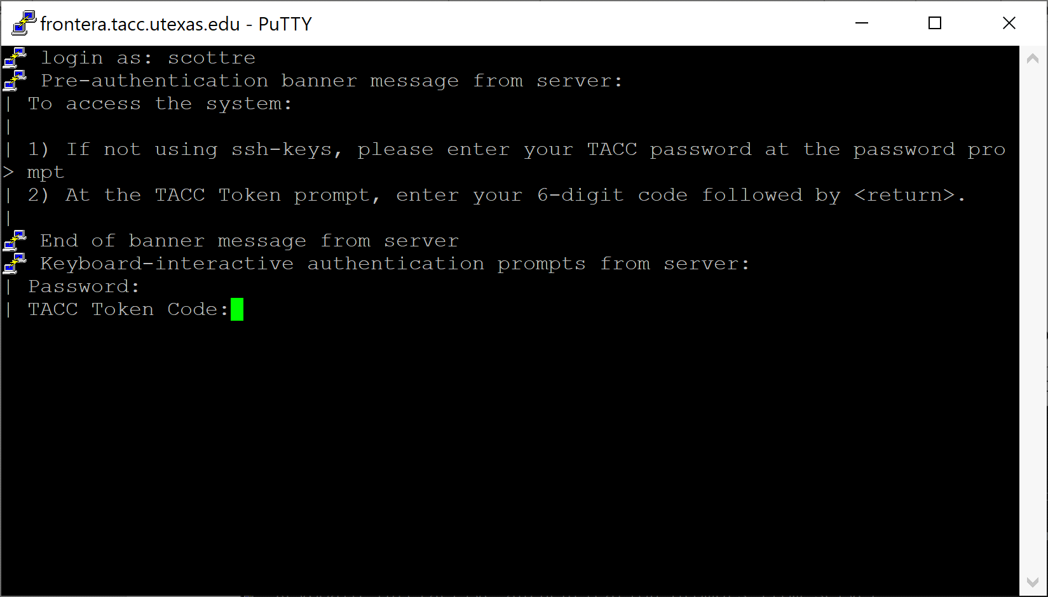

**Command Prompt:**

If you have WSL (Windows Subsystem for Linux) activated, you can use Command Prompt. Instructions to install WSL can be found here: <https://docs.microsoft.com/en-us/windows/wsl/install-win10>

* Press the Windows key and type “cmd”.
* Select “Command Prompt” from the Start menu.
* Type “bash” and press Enter to change to a bash shell.

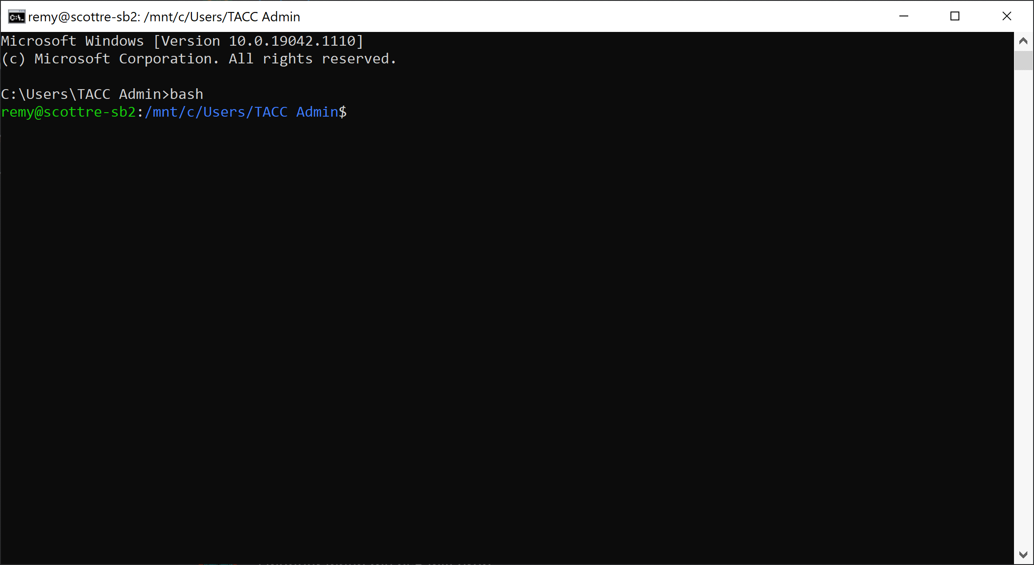

* From this prompt, you can ssh to a remote system:

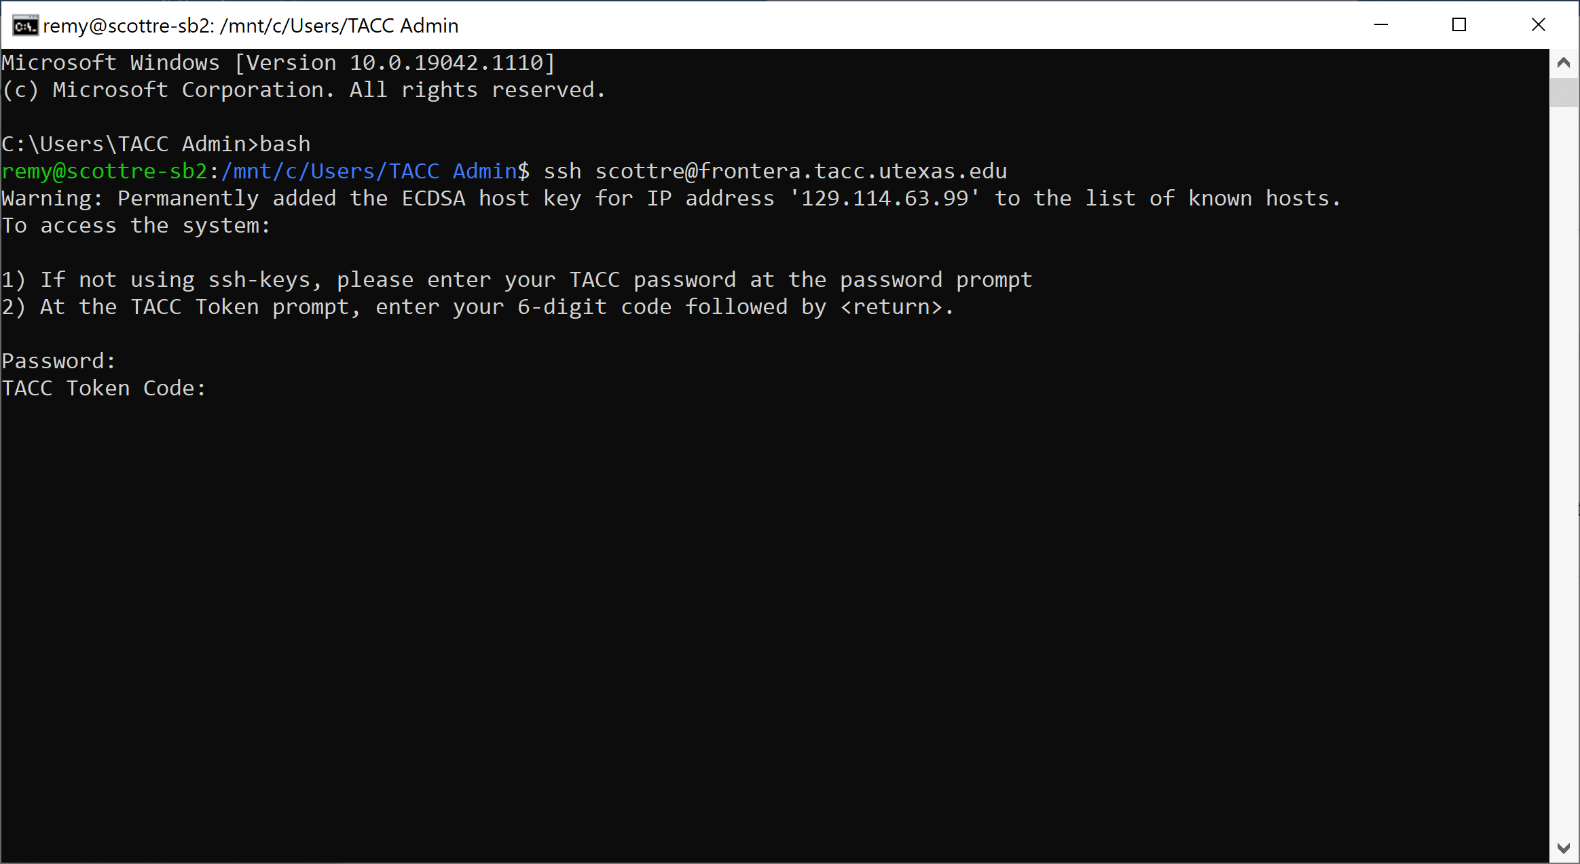

**Notes**

Other popular apps to use for a Linux-like experience using Windows:

* Windows Terminal. This app can be installed for free from the Microsoft Store in the Start menu and is installed by default on the latest Windows 10 versions.
* MobaXterm. Free and available for download from [https:// HYPERLINK "https://mobaxterm.mobatek.net/"m HYPERLINK "https://mobaxterm.mobatek.net/"obaxterm.mobatek.net/](https://mobaxterm.mobatek.net/). Side note: my personal favorite and have been using it for several years.
* Google Chrome secure shell Extension: [https://chrome.google.com/webstore/detail/secure-shell/iodihamcpbpeioajjeobimgagaj HYPERLINK "https://chrome.google.com/webstore/detail/secure-shell/iodihamcpbpeioajjeobimgagajmlibd"m HYPERLINK "https://chrome.google.com/webstore/detail/secure-shell/iodihamcpbpeioajjeobimgagajmlibd"libd](https://chrome.google.com/webstore/detail/secure-shell/iodihamcpbpeioajjeobimgagajmlibd). This a great option for Chromebooks.